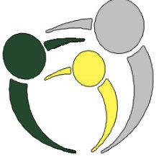
100 Youth Who Care
CBRM

To Become a Member You: complete this form and return to the address provided below.

I understand that I am making a commitment to 100 Kids & Youth Who Care CBRM to make an annual donation of $40.00 - ($10.00 at each of four meetings), given directly to local charities and non-profits in CBRM. I agree to fulfill my donation commitment even if I did not vote for the charity selected by majority vote. I also agree that I will provide my $10 to another member or the chair to deliver in my place if I am not able to attend a meeting. If you are under the age of 12 a parent or guardian must stay with you.

Name & Age: _______________________________________________________

Address: ___________________________________________________________

Phone: _____________________________________________________________

Email: ______________________________________________________________

School Attending:_____________________________________________________

Health: Are there any health concerns that we should be made aware of ? ____________________________________________________________________

Name 1 local charity you would like to nominate:____________________________

- I agree that all necessary and correct information has been provided.
- I understand that there will be circulation of photos and video and live stream from the events.
- I will commit to one year of donations.
- I agree that I will be picked up no later than 7pm following each meeting.

Member Signature ___________________ Parent/Guardian Signature____________________
Signature Signature

Completed Commitment Forms may be scanned and sent via e-mail to 100youthcbrm@gmail.com

*Should you wish to discontinue membership at any time, please send an e-mail to the above address indicating your withdrawl.

